COM161 – Practical 11

The purpose of today’s practical is the processing of Strings (see lecture 11)

Task 1

In the lecture, you were shown how to scrape information from a webpage and process it. Amend the code shown in the lecture (it’s in the Week 11 Lecture area) so that your code outputs how many times the letters of the alphabet appear in the text file.

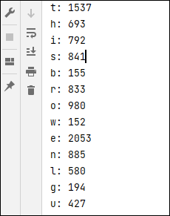

There are various ways to approach this problem. Determine which is the most suitable for you as a coder.

Task 2

Ask the user to read in a sentence from the keyboard and then print it out in reverse order.

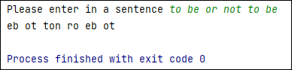

Task 3

Ask the user to read in a sentence from the keyboard and replace any numbers read in with X.

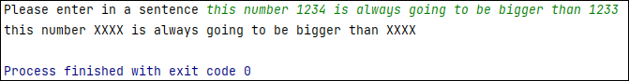

Task 4
Write a python program that looks for the substrings 'left' and 'up'. Swap 'left' with 'right' and 'up' with 'down'.
Test your code with the following examples:
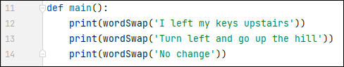

Which would give the following output:
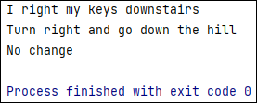

Task 5

Using the text file referenced in the lecture and Task 1, write a program that allows a user to search for key words or phrases in it.

